Opinion: 'A war on terror or the terror of war?'

Peter Offord Norwich Stop The War Coalition

Published: 1:30 PM August 23, 2021
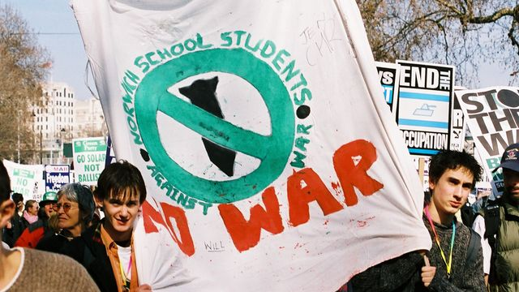
Soon after the Twin Towers exploded on our screens on September 11, 2001, Prime Minister Tony Blair gave a daunting speech that we would stand shoulder to shoulder with the United States. Shoulder to shoulder to do what, I shuddered? That afternoon the TV showed what appeared to be a Hollywood disaster movie, so incredible, I felt numb. Broadcasters grappled to find words as the planes struck the towers, to be followed by terrifying images of New Yorkers fleeing a volcano of ash and debris emitting from the World Trade Centre.
Not long after I was demonstrating with thousands, amidst a heavy police presence, at the Labour Party conference, calling upon Tony Blair to find a peaceful resolution to the situation, not war. We were reiterating the message sent out by many of families who had lost loved ones in the Twin Towers. By October I watched with a heavy heart as Blair spoke about global terror networks and that the dangers of inaction would be greater than the dangers of action. He made the ominous announcement that the Taliban, who were ruling Afghanistan and were harbouring the chief suspect Osama bin Laden, had not responded to the ultimatum to deliver him to the US. By then the national Stop the War movement was already formed and protesting.
Blair was relentless: "Action will be proportionate and targeted...we will do all we can to avoid civilian casualties". He accused the Taliban of supplying 90% of all heroin on British streets, he attacked their lack of women’s rights (taken up by Cherie Blair) and other abuses and atrocities. He said nothing about Saudi Arabia (our ally) from where the majority of hi-jackers had come, nor that that regime also committed human rights atrocities. We, the international community, would end the Taliban’s medieval and ‘barbaric’ theocracy and bring peace, stability and prosperity to Afghanistan. ‘The War on Terror’ so named by President Bush, was reframed as ‘Operation Enduring Freedom’. According to Bush, if other countries were not ‘with us’ then they would be ‘bombed back to the stone age’. Blair, ridiculed as ‘Bambi’ in The Daily Mail for his lack mettle, was out to show another side of himself.
Afghanistan, surrounded by Iran, Pakistan, Russia and later Soviet aligned states, was already bleeding from over 100 years of ‘The Great Game’ played out by foreign powers intervening to gain a geostrategic advantage. It was barely free of the decade of Soviet occupation, with few resources and under the yoke of the Taliban, who were in conflict with an assembly of armed Islamist groups with differing ideologies. Bin Laden and his family fled to the mountains and caves, in his words, to "protect the civilians of Kandahar". The Afghani people were subject to bombardment by thousands of cluster bombs, Tomahawk missiles and bunker busting bombs. The War on Terror had become a War of Terror.
But a ‘freedom’ did begin to emerge from the decades of trauma, with education for women, aid packages and huge contracts going to western, mainly US, companies. With money came corruption. Over 450 British troops died, with many more suffering life changing injuries, at a financial cost of £22-37bn to the UK taxpayer, roughly £2,000 per household. And the Afghan people? Despite US commander Tommy Franks’ utterance: "You know, we don’t do body counts", research institutes found that 241,000 people were killed in the Pakistan-Afghanistan war zone since 2001. At least 47,245 civilians died in Afghanistan and 24,099 in Pakistan.
Twenty years later the Taliban sped through to Kabul on battered pickup trucks with AK47s and RPGs whilst the most powerful and sophisticated military force of the western ‘civilised’ world scrambled in disarray to escape. Why?
Will this be the final lesson that foreign military intervention comes at a terrible cost to both the invaders and the invaded and that peace can only come through a long slow process of negotiation, tolerance and respect?

